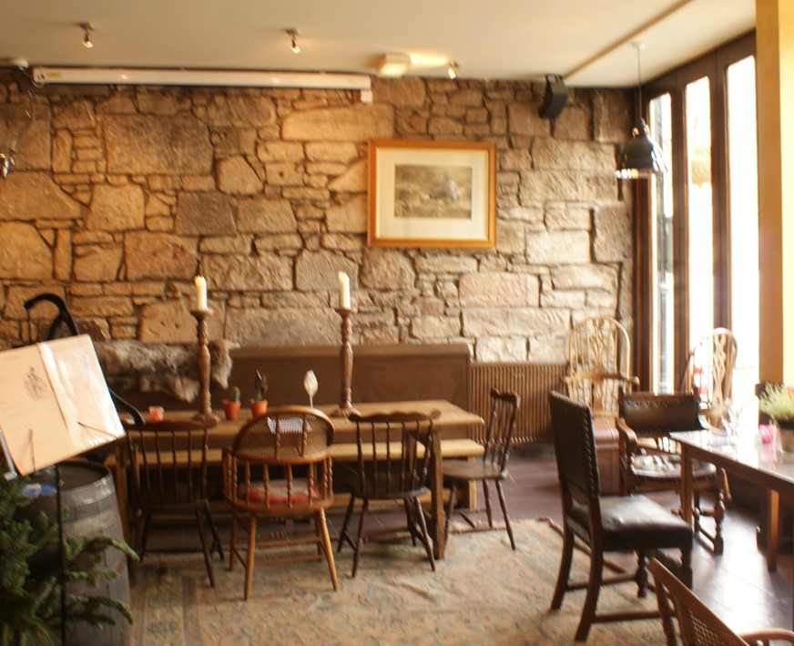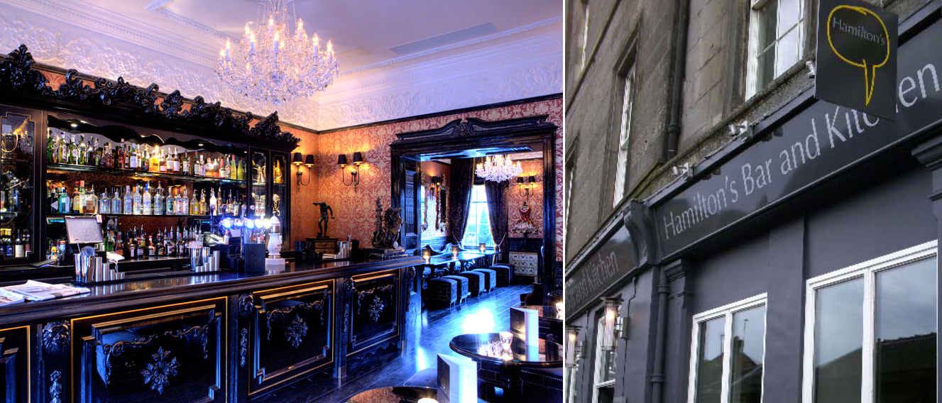

Mr/Mrs/Ms:
Surname:
Forename(s):
Address:
Date of Birth:
Telephone:
Mobile:
Email:
N.I. Number:

APPLICATION FORM

PLEASE COMPLETE ALL OF THE SECTIONS BELOW IN AS MUCH DETAIL AS POSSIBLE

Experience
Please use this area to provide details of relevant experience and/or training. Also include current and historical work history.

Trade/business qualifications & training
Please give below details of any qualifications or training relevant to your application

About the pub
If applying for a specific pub please state name and address of pub or give your preferred town/county to a maximum of three.

Why do you think you want to run your own pub?

Where did you hear about opportunities with Iona Pub Partnership?

Financial Details
Please give details of your source or potential source of funding.
Business Bank Details

Name as it appears on card

Unborrowed Cash £ Borrowed Cash £ Other (please state) £

Total £

Name & Address of Bank / Building Society

Sort Code / /

Account Number

Please give details of any county court Y / N
judgements? (please use a separate sheet if required)
Account Holder Signature

Personal Bank Details

Name as it appears on card

Have bankruptcy proceedings ever Y / N
been taken against you? (if yes, please give details)
Name & Address of Bank / Building Society

Do you have objections to Iona Pub Y / N Partnership carrying out a credit check
in your name?
Sort Code / /

Account Number

Account Holder Signature

Do you have any previous convictions? Y / N Are you subject to any pending criminal procedures Y / N

If ‘YES’, please give details of ALL criminal convictions (please use a separate sheet if required) Failure to disclose a conviction is subsequently discovered, this is in breach of your lease agreement and Iona will have no option but to irritate your lease.

DECLARATION: I declare that to the best of my knowledge, the information contained on this form is true and accurate and I understand that if any information is false or has been deliberately omitted, I may be regarded as ineligible to be lessee.

Signature Date

Do you have objections to IONA pubs carrying out a credit check in your name? Y / N

Applicant Signature Date

BDM Signature Date

