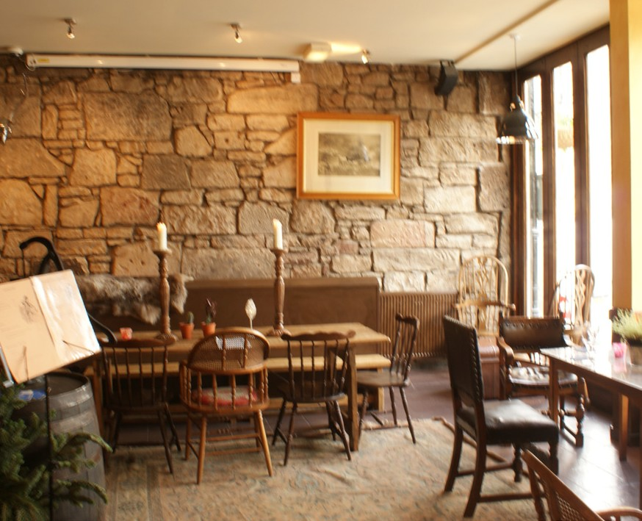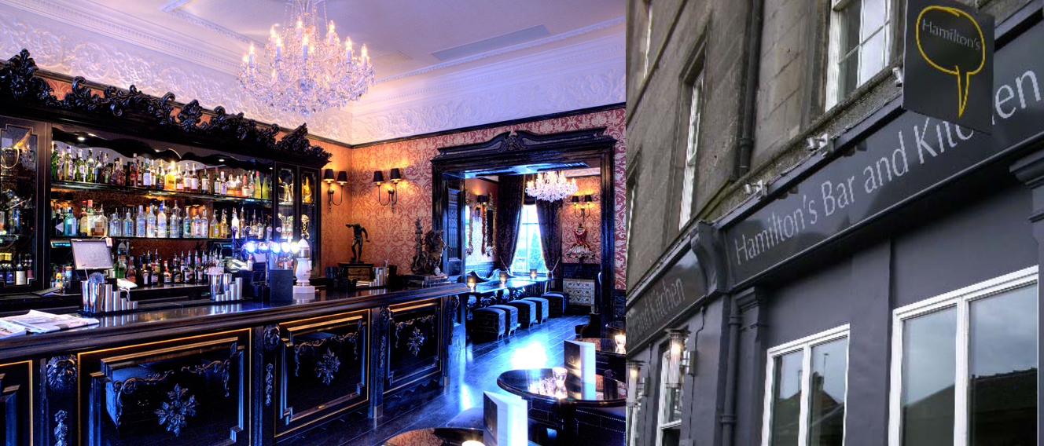

Pub Name:
Surname of Applicant:
Forename(s) of Applicant:
Address:
Date of Submittion:
Applicant Signature:

BUSINESS PLAN

PLEASE COMPLETE ALL OF THE SECTIONS BELOW IN AS MUCH DETAIL AS POSSIBLE. THIS DOCUMENT SHOULD BE A LIVING AND BREATHING PLAN FOR THE BUSINESS ONCE YOU ARE IN IT, SO PLEASE KEEP A COPY.

WHAT IS THE OUTLET LIKE NOW?
In this section you should use your current knowledge of what the outlet and area is like at the moment. If you don’t know then do the research as this will be invaluable information required to help make your business successful.

Area
What is the area like in which the pub sits? Is it rural, city centre? What is the surrounding area made up of - houses/business? Is the area affluent and how would other people describe it?

Location
Where is the pub situated within the area? Are there any developments planned which could affect the pub?

Customers
What kind of people live in the area and how can we make these potential customers? This should help about what your offer should be to attract the type of people in the area. For example, think about age ranges of people in the area, what sort of jobs do they have, what they enjoy doing in their spare time etc. You may want to use upmystreet.com to help with this if you do not know the area very well.

Competition
Please list all of the competitors in the area, describe what they offer, their strengths and weaknesses and also what you would offer within your business to try and compete.

CURRENT VIEW OF THE PUB
Please highlight under each heading where you see and want to take this pub

Strengths
What are the good things about the pub at the moment?

Weaknesses
What are the bad things about the pub at the moment?

Opportunities
What can you introduce to make this a more successful business?

Threats
What could stop you making this a successful buisness?

Offer
What will you offer customers coming into your pub? Think about food and attach any sample menus, entertainment, opening hours, atmosphere, decor, drinks range, etc.

Customers
Who will be your customers? Will they be different in the evenings as opposed to daytimes? Who will you attract at weekends? Think about age types, gender and profession.

Marketing
How will you market your pub and let the surrounding area know what you will be offering?

Additional Information
Please add any information/plans which you think may be relevant to the business plan.

Finances
Please complete the following profit and loss account.

HOW MUCH IS YOUR BUSINESS GOING TO TAKE?
PROJECTED PROFIT AND LOSS ACCOUNT FOR THE FIRST YEAR OF TRADING

PROJECTED INCOME (turnover) | Weekly £ | Annual £
Liquor (wet sales)
Less cost of sales
Gross profit (turnover) a

Food (dry sales)
Less cost of sales
Gross profit (turnover) b

TOTAL GROSS PROFIT (a+b=A) A

Other income
Gaming Machines
Accomodation (if applicable)
Other (e.g. Functions)
Total other income B

GRAND TOTAL (A+B=C) C

NOTES...

HOW MUCH IS YOUR BUSINESS GOING TO TAKE?
Continued...

PROJECTED EXPENDITURE (overheads) | Weekly £ | Annual £
Rents
Rates
Cleaning
Insurance
Equipment Hire
Machine Rental
Wages: Bar Staff
Kitchen Staff
Cleaning
Electricity Gas & Oil
Plants & Flowers
Repairs & Renewals
General Administration
Vehicle Costs (tax, insurance, running costs, etc...)
Entertainment
Advertising
Licenses
Legal and Professional costs
Maintenance
Bank Charges
Subscriptions
Other, please specify:
TOTAL COSTS D

TOTAL GROSS PROFIT (see previous page) C

PERSONAL REQUIREMENTS/COMMITMENTS

ANNUAL EXPENDITURE (these are costs that you will incur outwith the business)
Mortgage or Domestic Rent
Council Tax
Water Rates
Utilities
Personal and Property Insurance
General Housekeeping Expenses
Telephone
HR Repayments
Hire Charges
Saving Plans
Contingencies
Pension Plans
Personal Loans
Other, please specify:
TOTAL EXPENDITURE F

ESTIMATED ANNUAL INCOME (i.e. not from the pub)
Total income from family/partner
Other income, please state source:
TOTAL INCOME G

Notes

www.ionapub.com

